REPORT TO PARISH COUNCILS
FROM COUNTY COUNCILLOR
AUGUST 2014

Condolences

I was deeply saddened to hear of the death of the Parish Council Vice Chairman and offer my condolences to all who knew Tracy well.

Local Issues

Earlier this month I had the chance to spend a half day at the Deddington Highways Depot to understand how the team works in detail. It was really interesting to see the processes that go into all sorts of highway repairs all over the county including understanding the colour coding for spray around potholes and watching one of the new machines at work. This machine can fill in a pot hole in almost any weather and does nor require road closures. Given how it works, it’s only suited to rural areas and not towns or cities so I can see this being of benefit to all my villages. I have attached a couple of pictures of the pothole machine in action, alongside the obligatory picture of the county councillor in a hard hat…The whole process takes about 20 mins to fill a pothole (note, I didn’t fill in the pothole!)
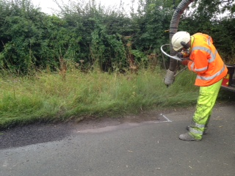
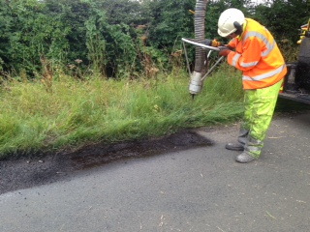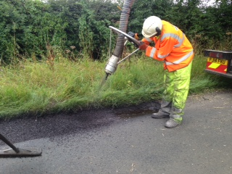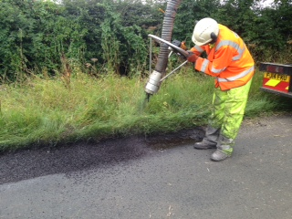
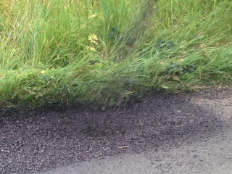

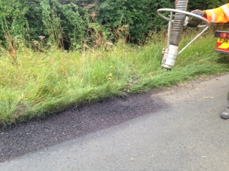

GROWTH DEAL HERALDS NEW ERA FOR OXFORDSHIRE ECONOMY

The Deal will see at least £108.6 million invested in Oxfordshire with £15.7 million confirmed in the first year. In addition, as part of the Government’s on-going commitment to the Oxfordshire LEP, it has provided an indicative award of a further £92.9million of funding from 2016/17 onwards. This Deal will help to create up to 5,700 jobs, allow over 4,000 homes to be built and generate over £100m in public and private investment.

The key features of the deal are:
- Investing in substantial measures to reduce the risk of flooding, so that businesses can continue to operate, roads and railway lines are kept clear and people can be confident that their homes and businesses won’t be damaged;
- Investing jointly with the University of Oxford in a new Centre for Applied Superconductivity, which will bring university professors and entrepreneurs together to collaborate on exciting developments in fields as diverse as computing, cryogenics, x-rays and MRI scanning and electricity storage;
- Investing with the City of Oxford College, and Abingdon and Witney College, in state-of-the-art skills centres that will train local people in science, engineering and technology, providing them with the skills they need to get a job;
- Significant investment in better transport links including roads, parking and cycling networks – joining up Oxfordshire’s world class universities with its businesses and helping people get to where they need to be faster;
- Additional investment into the Oxfordshire Growth Hub to help local businesses access support and make the connections they need to grow.

The Oxfordshire Growth Deal is part of a national £12 billion long-term programme to revitalise local economies. The deals are the latest and greatest example of the British economy being rebuilt from the bottom up, and sharing the benefits of the recovery around the country. Local businesses and council leaders have been invited to open discussions immediately on the next set of projects to be funded, building on the momentum that has been established.

LAUNCH OF OXFORD STATION MASTERPLAN

A masterplan for Oxford Station was launched on Thursday 24 July, setting out a long-term vision for major improvements to the station and surrounding area.

The ambition of the plan is to create an exemplary gateway to the city that meets Oxford's long-term rail needs and acts as a focus for investment.

The proposals call for higher quality public space, in and around the station and significant changes to accommodate the expected increase in rail passenger numbers over the next few years.

The main features include: a new station building, new rail track and platforms, a transport interchange - including bus station and multi-story car park, development opportunities, better cycle facilities and improvements to Botley Road bridge.

Oxford City Council, Oxfordshire County Council and Network Rail are working together to develop the masterplan, in conjunction with the Department for Transport and First Great Western

More information at: https://www.oxfordshire.gov.uk/cms/news/2014/jul/launch-oxford-station-masterplan

DRAFT LOCAL FLOOD RISK MANAGEMENT STRATEGY CONSULTATION

This consultation is to gather views on the draft Local Flood Risk Management Strategy for Oxfordshire, which:
- Sets procedures for identifying the relative priorities of measures for reducing local flood risk (i.e. from surface water, groundwater and ordinary watercourses such as rivers.
- Establishes how to identify areas where a ‘holistic approach’ to flood risk management will achieve multiple benefits.
- Establishes how to identify affordable measures for implementation to agreed time frames Facilitates engagement and consultation with the community and all our partners
- Encourages public awareness and self-help where appropriate

It is open until 19th September with more information at: https://consultations.oxfordshire.gov.uk/consult.ti/floodriskmgmt/consultationHome

ACADEMIC RESEARCH OPEN TO ALL COUNTY RESIDENTS

The County Council’s library service has joined forces with the Publishers Licensing Society and Society of Chief Librarians leading to the computers at all 43 of Oxfordshire’s libraries being linked up to a system that allows online access to research of many varieties.

Called “Access to Research”, the service offers access to research literature on art, architecture, business, engineering, history, languages, politics, philosophy, mathematics and the sciences, medicine and health and social sciences.

More information at: https://www.oxfordshire.gov.uk/cms/news/2014/jul/oxfordshire-libraries-bring-academic-research-all-county-residents

SUMMER READING CHALLENGE FOR ADULTS

People across Oxfordshire are being invited to share their enthusiasm for books at a series of special events as part of the county council library service’s Summer Reading Challenge for Adults.

More information at: https://www.oxfordshire.gov.uk/cms/news/2014/jul/come-dine-us-oxfordshires-libraries

COUNTY HALL COMMEMORATES THE FIRST WORLD WAR

Oxfordshire County Council will be turning its ‘lights out’ as part of a special service to commemorate 100 years since the outbreak of the First World War on Monday 4th August. The event is a national campaign, which invites people from all over the country to turn off all the lights in their building and leave just one on in remembrance of those who served during the war. The event is inspired by the words of the then foreign secretary Sir Edward Grey, who said: “The lamps are going out all over Europe; we shall not see them lit again in our lifetime.”

More information at: https://www.oxfordshire.gov.uk/cms/news/2014/aug/county-council-turns-%E2%80%98lights-out%E2%80%99-commemorate-fallen-heroes

OXFORDSHIRE AT THE COMMONWEALTH GAMES, GLASGOW 2014

Congratulations to all athletes who competed at the Commonwealth Games in Glasgow. England came top of the table with Oxfordshire well represented. Dan Rivers of Didcot won gold in the 50m 3p Rifle and bronze in 10m Rifle Event and Oxford-born Matt French won silver in the double trap clay pigeon shoot. As part of the Women’s Hockey Team, Zoe Shipperley of Marsh Gibbon claimed silver and Ben Watson of Didcot won bronze in Men’s 105kg Weightlifting. In athletics, Hannah England of Oxford reached the final of the women’s 1500m and Nathan Douglas, also from Oxford, competed in the triple jump.

CONSULTATION ON ORAL HEALTH

Oxfordshire County Council is planning to commission oral health promotion and epidemiology services. We would welcome thoughts and experiences about current and potential future services. The commissioning survey is open until 10th August.

More information at: https://consultations.oxfordshire.gov.uk/consult.ti/Oral_Health/consultationHome

SUCCESSFUL TRAFFIC MANAGEMENT FOR GAME FAIR

The CLA Game Fair returned to Blenheim Palace in July. Some changes were made to the traffic management programme since the previous event in 2011. The plans worked well and there was minimal disruption to local circulation. The event itself was a success, with over 150,000 visitors enjoying the show and bringing millions of pounds into the local economy. The hotels, B & Bs, pubs and restaurants all had a busy weekend and returning visitors will add to our economy.

